2007

Diana Dukart
OMSE 551 Strategic Software Engineering
11/29/2007
Test Executive Commonality Analysis
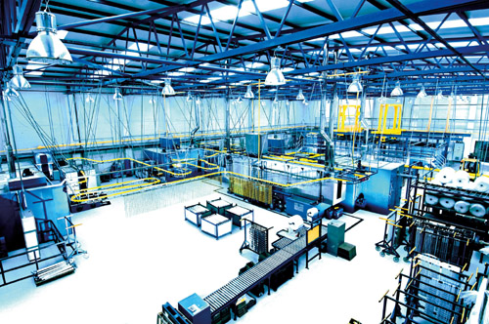

- Introduction
Manufacturing Test Executive (MTE) systems are deployed to manufacturing lines and used by operators to run a series of tests on each piece of hardware manufactured or otherwise known as the “Unit Under Test” (UUT). The MTE is responsible for the following functionality:
  - Run tests specified by either the operator or another system.
  - Validate test equipment on the test bench with the list stored in the Equipment Manager System. Display a message to the operator if there is a mismatch.
  - Communicate with necessary test equipment on the test bench during testing.
  - Store all specific UUT information (e.g. Model, Serial Number, etc.) and test results during testing.
  - Log stored data to a specified database through the local area network (LAN) at the end of each test. Store data locally if the LAN is unavailable and attempt to log again at the completion of the next test or at the request of the operator. (Some MTE systems always run offline.)
  - Create and display a report of test results at the end of each test. Store each report locally on the system. If a network path is specified, store a second copy of the report on the network when the LAN is available.
The purpose of this analysis is to specify the foundation on which to build a family of MTE systems. Since a Return on Investment (ROI) feasibility study was not completed, this analysis will also be a first cut on determining if developing a family for MTE systems will be feasible and pay in the long run. In addition, the ability to specify the configuration of a specific MTE system will be realized from this work.
Figure A.1 is a picture of a Manufacturing Test Bench that contains a Manufacturing Test Executive System.

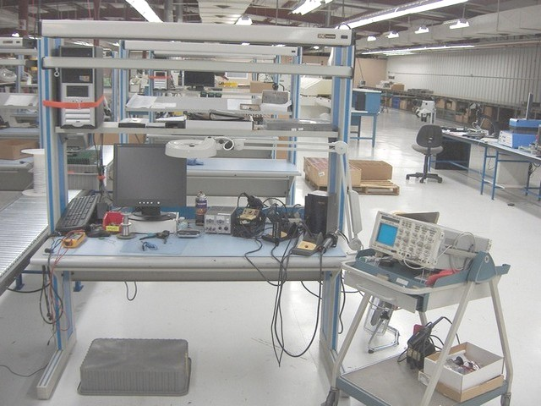
Figure A.1 Manufacturing Test Executive System
- Overview
The following concerns will be the focus of this commonality analysis.

- What is common in the software between test systems that can feasibly be reused?
- What decisions must be made by the Test Engineers when creating a new test system to handle the variabilities?

Interfaces to Other Domains
Each MTE system will interface to an Oracle database. (In reality, there will be more than one database, but for simplicity of this exercise, I will treat the many databases as one. However, I do capture that you can change which database you are logging to.) The database is used by the MTE system to interact with the Equipment Manager System to validate the correct test equipment is on the test bench. The database is also where the test data and UUT information MTE logging happens. As far as how the MTE system impacts end customers, the Calibration Record System uses the same database to print test and UUT data on the Certification Reports. The Certification Reports will be shipped to the customer with the manufactured unit.

The Manufacturing Test Executive system will also interface with the different test equipment on the test bench. In addition, it will interface with the actual hardware unit being manufactured and tested. Finally, it may interact with the network to store test reports depending the system’s configuration. (There are also interactions with another system, the Manufacturing Execution System [MES], however; I am leaving this piece out for simplicity.) Figure A.2 is a picture of the interfaces that exist in the MTE domain.

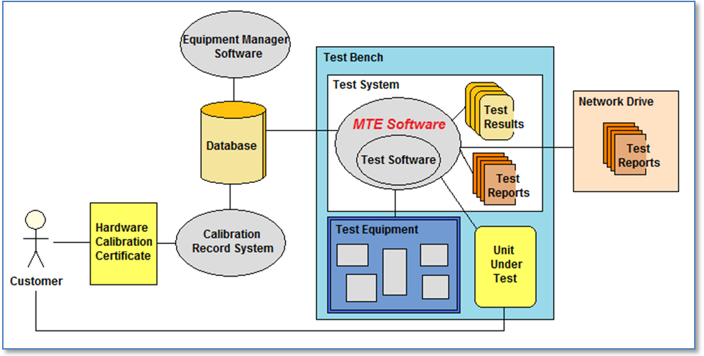
Figure A.2 Interfaces to the MTE Software
- Dictionary of Terms
Error An error occurs during a test when there is a problem with the test system or execution of the test. For instance, when the operator forgets to hook up a cable or the software has a bug; these are both errors.
Failure A failure occurs during a test if the UUT returns a value that is out of range of the specifications for that hardware. For instance, if a result of 0 to 10 volts is expected as a measurement from the UUT, but it returns 13 volts; this is a failure.
Test Bench Physical bench that contains a test system and test equipment. Hardware units will move to a test bench as a step in the process of the manufacturing line.
Test Engineer Person who writes the software that tests hardware being manufactured and is responsible for maintaining test benches.
Test Equipment Hardware components necessary to test the hardware unit being manufactured. This includes everything from an oscilloscope to a cable.
Test Sequence Group of tests.
Test System Computer that contains the Manufacturing Test Executive system software and any other required components (e.g. Test Results, Test Reports, Hardware Drivers, etc).

- Commonalities
Basic assumptions about the commonality of the MTE domain are listed below. These statements need to be true for all MTE systems that are a part of the MTE family.

Behavior
- At the start of each test, the test equipment on the test bench is validated against the Equipment Manager System. (see Issue 1)

- After test equipment validation, information is requested: Model, Serial Number, Test Sequence, Employee ID, and Options. (see Issue 2)

- After information is gathered, tests are executed. (see Issue 3)

- Test results are stored in memory while the tests are running.

- Error and Failure handling is managed by changing the test status and displaying a dialog with options to the Operator. The options are Continue Test, Terminate Test, or Retry. (see Issue 4)

- After test sequence completion, the information gathered previously along with the test results is logged. (see Section A.11 Test Logging)

Devices
- The database software driver is installed on each MTE System.

- All database connection strings are stored in a UDL file on each MTE System. (see Issue 5)

- Each piece of test equipment has a unique identifier. (see section A.10 Test Equipment Unique Identifiers)

- Variabilities
The list of statements below describes how members of the MTE family can differ.

Behavior
- The Tests that are executed can vary.

- The Test Equipment that is used for testing can vary. (see section A.9 Test Equipment Management)

- The MTE system can run online or offline. (see section A.11 Test Logging)

- The database to which the MTE System connects can vary. (e.g. Production vs. Test, China vs. Beaverton, etc.)

- The system can automatically generate a series of serial numbers or the serial numbers can be entered individually.

- Test Report generation can vary.

- Test Report storage on the network can vary.

- Ability to run in Simulation Mode can vary. (see section A9 Simulation Testing)

Devices
- The hardware being tested can vary.

- The quantity of test equipment on the bench can vary. Having no equipment is valid.

- The type of test equipment on the bench can vary. (see section A.9 Test Equipment Management)

- The device drivers installed on the MTE system for the test equipment can vary. (see section A.9 Test Equipment Management)

- The device driver installed on the MTE system for the database can vary.

- Parameters of Variation
The parameters of variation and the connections to the variabilities are shown in Table A-1.
Table A-1: Parameters of Variation
Parameter | Meaning | Value Space | Binding Time | Default
P1: TestCode, V1 | The Test Code that will be executed on the MTE system. | [List of Test Code] | Specification | Empty List
P2: EquipList, V2, V10, V11 | List of test equipment on the bench with unique identifiers. | [List of Equipment] | Specification | Empty List
P3: Online, V3 | Identifies whether the MTE system will connect to the network or not while testing. | [Yes, No] | Integration | Yes
P4: Database, V4 | Specify which database to connect. Even if P3 is set to No, this will need to be set for the times when the MTE system is synchronized with the database. | [UDL File Name] | Configuration | Beaverton Production
P5: SNGen, V5 | Automatically generate Serial Numbers (Yes) or enter each separately (No). | [Yes, No] | Integration | No
P6: ReportGen, V6 | Generate a Test Report or Not. | [Yes, No] | Configuration | Yes
P7: NetworkReport, V7 | Store a second copy of the report on the network. If P6 or P3 is No, this does not need to be set. | [Null, Network Path] | Configuration | Null
P8: SimulationMode, V8 | Ability to run tests in simulation mode. | [Yes, No] | Specification | Yes
P9: UUTType, V9 | Type of product being tested. | [Oscilloscope, Logic Analyzer, Probe, etc.] | Specification | Empty
P10: DriversList, V12, V13 | List of device drivers that need to be installed on the system. | [List of Device Drivers] | Integration | Empty List

Table A-2 shows what the binding times represent in the Parameters of Variation table.
Table A-2: Binding Time Descriptions
Binding Times | Description
Specification | Decision is in the Requirements document and impacts implementation.
Integration | Decision is a direct impact on which pieces are integrated together.
Configuration | Decision is in a configuration file read by the system at runtime.

- Issues
Issue 1 What happens if the test equipment validation fails?
Resolution: If there is a discrepancy, a warning is displayed to the operator and the test is terminated with a Failed status.

Issue 2 How is information requested?
Resolution: There are several ways information can be gathered: Manual Entry, Barcodes, UUT interface, MES interface, etc. Since these options are available on every system, they are not added as variability. In addition, I did not specify all the data being requested to keep it simpler.

Issue 3 How is it decided which tests to run?
Resolution: The test sequence is once piece of information gathered at the start of execution. The test sequence is what maps the system to the list of tests to run. This is simplified, however; since there can be more than one test sequence executed at one time and handling this is complex. Order, level of tests, interaction, validation, etc. are just a view issues.

Issue 4 How is the test status handled?
Resolution: Error and failure handling is the most complex piece of the system. I have left out the handling of indeterminate and uncertainty. In addition, there are different levels of retrying. The failures and errors are handling separately (see the dictionary of terms to understand the differences), which complicates things when they both occur. For example, when an error occurs it will replace a failed status, however; if the error is retried the status cannot be reset to pass since there is a failure that occurred that was not retried. This means the management of the state becomes harder and other issues arise the further you dig into this. Finally, there are many different statuses within the system. The running status, step status, sequence status, single test status, status of a group of tests, etc. I am not going to touch on any of these in this analysis.

Issue 5 How are database connection strings protected?
Resolution: The UDL files are encrypted with a whole other process involved to decrypt for use.

- Simulation Testing
The MTE systems have the ability to run in simulation mode. This means no hardware is required and the goal is to improve testing of the MTE software. The decision to implement simulation mode must be up front because simulation code must be integrated into each module’s code. Basically an extra case is added (generally randomly generating specified results) in which instead of connecting to hardware, other functions are executed. This not only speeds up testing the functionality of the system (rather than fighting with hardware that is not completely running yet), but is also saves money on the capital expenses of providing each engineer with hardware to use for testing at their desks.

- Test Equipment Management
The test equipment is managed in the Equipment Manager System. How equipment is used and deployed to different MTE systems can vary. First, there is a behavior variability in connecting to different pieces of hardware for different tests. For example: Hardware A, B, and C are on the bench. Test 1 connects to B and C. Test 2 connects to A, B, and C. Test 3 connects to C.

There is also variability in the test equipment on the bench. For example Bench 1 may have test equipment A, B, and C; but Bench 2 has test equipment D, E, and F. There will never be sharing of equipment between test benches since these are physical locations and a piece of hardware can only be in one place at one time. However, the variance of test equipment drivers is different. These are installed on the MTE system and the same exact driver can exist on more than one system. Each system can have a different set of drivers though.

- Test Equipment Unique Identifiers
The Test Equipment has unique identifiers assigned to them in the Equipment Manager. They have an asset number assigned to them that is unique to the Equipment Manager (e.g. 123456). They also have a logical name assigned to them that is unique for the MTE system to which they are linked. The logical name is setup by the Test Engineer in charge of the MTE system. The naming convention they use is a short name plus a number. So for instance, a digital multimeter would have the logical name dmm1. If there is more than one digital multimeter assigned to the MTE system, then the second one would have the logical name dmm2. They would each have a unique asset number that would never change while they are tracked in the Equipment Manager, however; the logical name could change if they are moved to a different MTE system or the Test Engineer needs to change it for some other reason.

- Test Logging
A test system can be configured to run offline. This means everything will be logged locally until the system is synchronized with the database (all local data is pushed into the master database). When a test system is configured to run online, but the network and/or the database is down, everything again is logged locally. This data is logged to the database either when another test completes and obtains database connectivity or there is an operator request to log the local data. A test system that is configured to run offline has extra functionality installed on the local machine (i.e. local equipment manager, local database [instead of files], local report generator).

- Decision Model for MTE Family
Decision | Order (Phase)
Type of hardware to test | 1
Tests to execute | 1
Equipment used in testing | 1
Simulation testing ability | 1
Online or offline test mode | 2
Hardware drivers needed | 2
Serial number generation | 2
Database to use | 3
Report generation ability | 3
Network report storing ability | 3

- ROI for MTE Family
This analysis gives a broad overview of the commonalities and variabilities of the MTE systems. It shows there are many elements in common between the different versions of the system. It also shows some of the variabilities are configurable; many of them can be handled by creating a configuration file that could potentially be updated out on the manufacturing line to change how a system behaves or executes. This flexibility could potentially get products out the door faster and make the company more money. In addition, bringing stations up faster and decreasing test system maintenance costs with improved quality and shared testing resources will also save the company money. In other words, it will pay to do further analysis on making these systems into a product line.

Bibliography
[1] Weiss, David M., and Chi Tau Robert Lai. Software Product-Line Engineering: A Family-Based
Software Development Process. Reading, Massachusetts: Addison-Wesley, 1999.

